MOVIE BOOKING SYSTEM

1. Title Page
- Project Title: Movie Booking System
- Student Name: MADESH S
- Register Number: 921724115023
- Department: COMPUTER SCIENCE AND DESIGN
- College Name: SETHU INSTITUTE OF TECHNOLOGY
- Course: Programming in C
- Guide/Trainer Name: BALAJI B
- Submission Date: 26.02.2026

2. Abstract
This project is a console-based application designed to automate the process of booking movie tickets. It allows users to select from a list of available Tamil movies, view a real-time seat map (showing available 'O' and booked 'X' seats), and book multiple tickets. The program calculates the total cost based on a fixed price and updates the seating arrangement automatically.

3. Introduction
- What problem you are solving: It replaces manual ticket tracking with a structured digital system to prevent errors and overbooking.
- Why this project is useful: It provides an easy-to-use interface for users to see exactly which seats are available before purchasing.
- Where it can be used: It can be used in small cinema halls, drama theaters, or as a foundation for a larger theater management system.

4. Objectives
- Understand structured programming.
- Use loops and conditions to manage seat allocation.
- Work with arrays and functions to maintain movie data.
- Improve logical thinking in software development.

5. Tools & Technology
- Programming Language: C
- Compiler: GCC / Turbo C / CodeBlocks
- Platform: Windows / Linux

6. System Requirements
- Hardware: Basic computer with minimum 4GB RAM.
- Software: C Compiler and any IDE/Text Editor.

7. Methodology / Algorithm
- Start program.
- Display menu of available movies.
- Read user input for movie selection and ticket count.
- Process logic by updating the 2D array and calculating the total price.
- Display output summary and updated seating chart.
- End program.

8. Flowchart

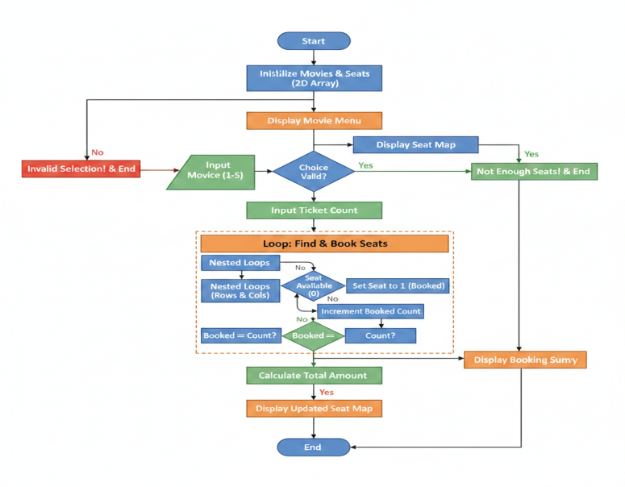

9. Program Code
#include <stdio.h>

#define ROWS 8
#define COLS 10
#define PRICE 150

struct Movie {
char name[50];
int seats[ROWS][COLS];
};

void displaySeats(int seats[ROWS][COLS]) {

int r, c;

printf("\n\n SCREEN THIS WAY\n");
printf(" -------------------------------------------------\n\n");

printf(" ");
for(c = 0; c < COLS; c++)
printf(" %2d", c + 1);
printf("\n");

for(r = 0; r < ROWS; r++) {
printf(" %c ", 'A' + r);
for(c = 0; c < COLS; c++) {
if(seats[r][c] == 0)
printf(" O");
else
printf(" X");
}
printf("\n");
}

printf("\n O = Available X = Booked\n");
}

int main() {

struct Movie movies[5] = {
{"Leo", {0}},
{"Jailer", {0}},
{"Vikram", {0}},
{"Master", {0}},
{"Thunivu", {0}}
};

int choice, ticketCount;
int totalAmount = 0;
int booked = 0;
int totalSeats;
int r, c, i;

printf("============================================\n");
printf(" TAMIL MOVIE BOOKING SYSTEM\n");
printf("============================================\n\n");

printf("Available Movies:\n");
for(i = 0; i < 5; i++)
printf("%d. %s\n", i + 1, movies[i].name);

printf("\nSelect Movie (1-5): ");
scanf("%d", &choice);

if(choice < 1 || choice > 5) {
printf("Invalid Selection!\n");
return 0;
}

displaySeats(movies[choice-1].seats);

printf("\nEnter number of tickets to book: ");
scanf("%d", &ticketCount);

totalSeats = ROWS * COLS;

if(ticketCount > totalSeats) {
printf("Not enough seats in theatre!\n");
return 0;
}

for(r = 0; r < ROWS; r++) {
for(c = 0; c < COLS; c++) {

if(movies[choice-1].seats[r][c] == 0) {

movies[choice-1].seats[r][c] = 1;
printf("Seat %c%d Booked\n", 'A'+r, c+1);
booked++;

if(booked == ticketCount)
break;
}
}
if(booked == ticketCount)
break;
}

totalAmount = booked * PRICE;

printf("\n============================================\n");
printf(" BOOKING SUMMARY\n");
printf("============================================\n");
printf("Movie Name : %s\n", movies[choice-1].name);
printf("Tickets Booked : %d\n", booked);
printf("Price Per Ticket : Rs.%d\n", PRICE);
printf("Total Amount : Rs.%d\n", totalAmount);
printf("============================================\n");

displaySeats(movies[choice-1].seats);

printf("\nEnjoy Your Movie!\n");

return 0;
}
can you give me the full questions answers in the pdf according to the code

10. Sample Input / Output

Select Movie: 1

Enter number of tickets to book: 2
Seat A1 Booked
Seat A2 Booked

BOOKING SUMMARY
Movie Name : Leo
Tickets Booked : 2
Price Per Ticket : Rs.150
Total Amount : Rs.300

11. Result
The program executed successfully and produced the expected output, allowing for dynamic seat allocation and price calculation.

12. Applications
- Learning programming.
- Academic practice.
- Beginner software development.

13. Conclusion
The project demonstrates basic C programming concepts and their application in a real-world scenario.

14. Future Enhancements
- Add file handling to save booking data.
- Improve user interface.
- Extend features like seat selection or cancellation.

15. References
- C Programming books.
- Online tutorials.
- Class notes.

